**Name:_________________________________**

**Job Shadowing Thank You Letters**

***After reviewing the tips, write your thank you letter rough draft on the back or a separate sheet of paper.***

**THANK YOU LETTER/ CARD CHECK LIST:**

1. **Proper salutation** -- capitalized name, punctuation: 
2. **Begin with gratitude** -- express your thankfulness: 
3. **Express detail** -- include the best part of the experience & any points you forgot to make in person: 
4. **Future plans** -- explain how this experience will influence you:
5. **Closing salutation** – end with “Sincerely, your name” or “Thanks, your name”: 

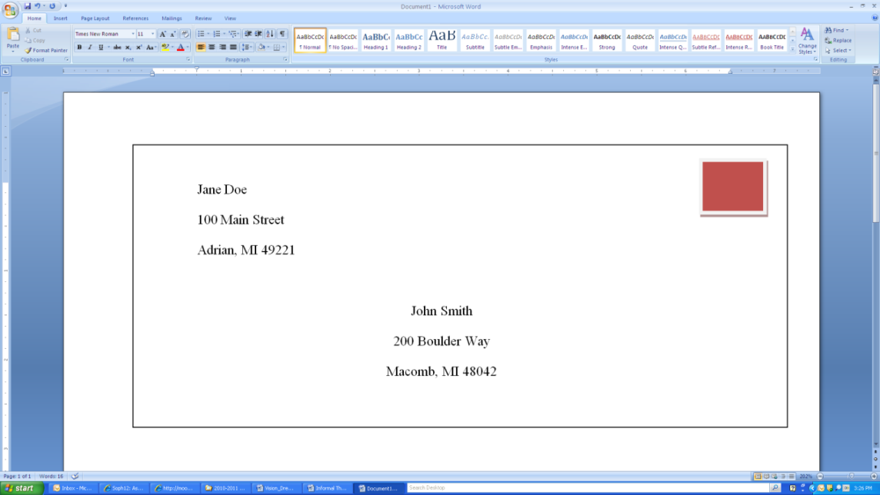

Example: Jane Doe is sending

a thank you note to John Smith

Practice writing out an envelope here: